Case Study Submission Template

- Name : Yuvaraj D

- Employee Id : 1187505

- Email Id : yuvaraj.d4@tcs.com

- Your Git Repository URL : https://github.com/yuvi1695/batch10.git

- Attach the screenshot of your Dockerfile.

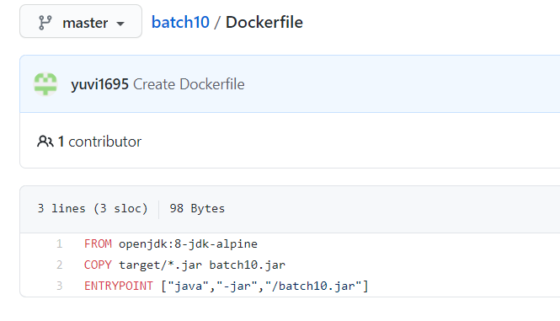

- Attach the screenshot of your Jenkinsfile.

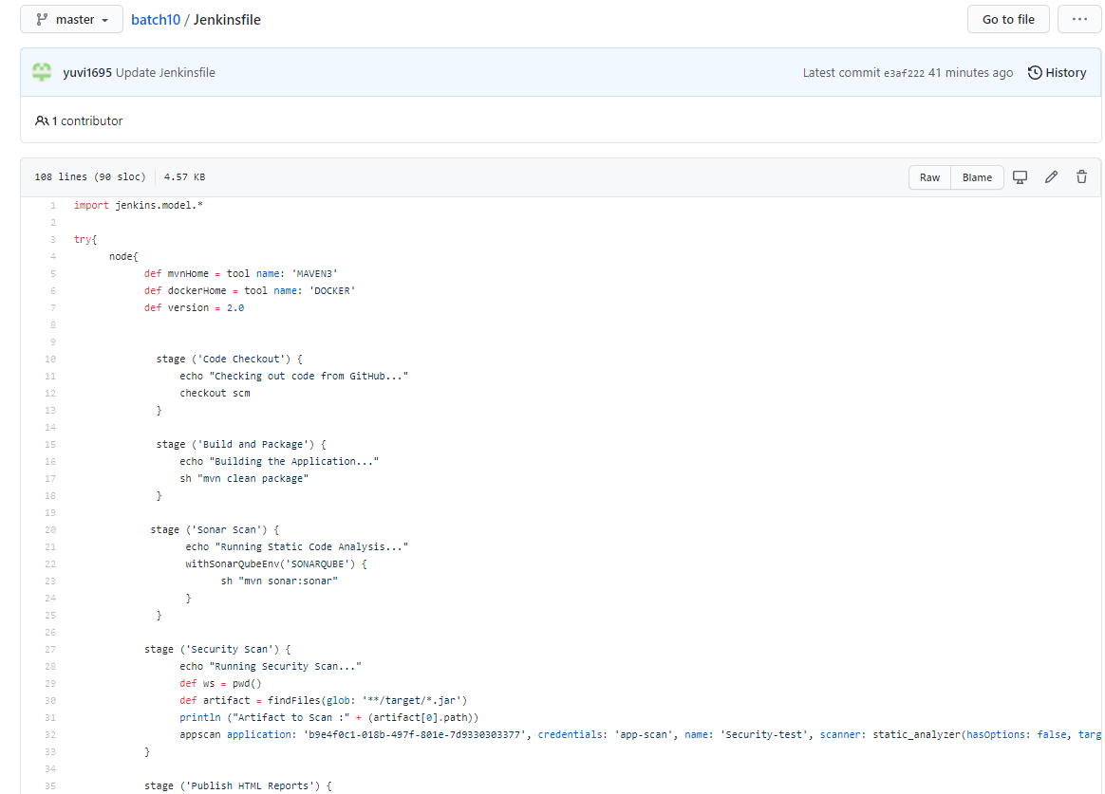
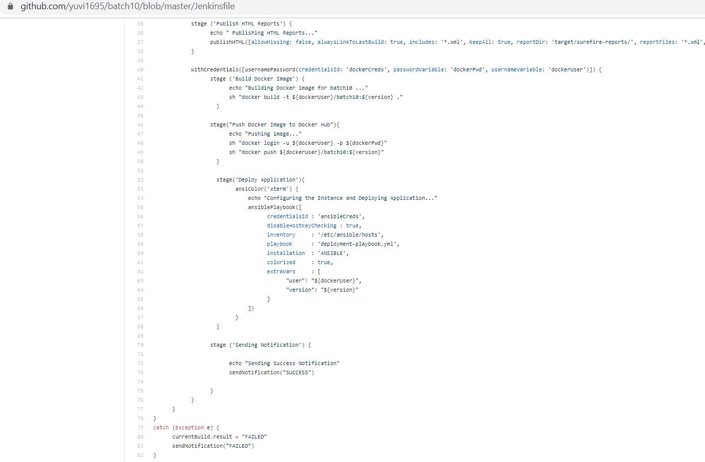
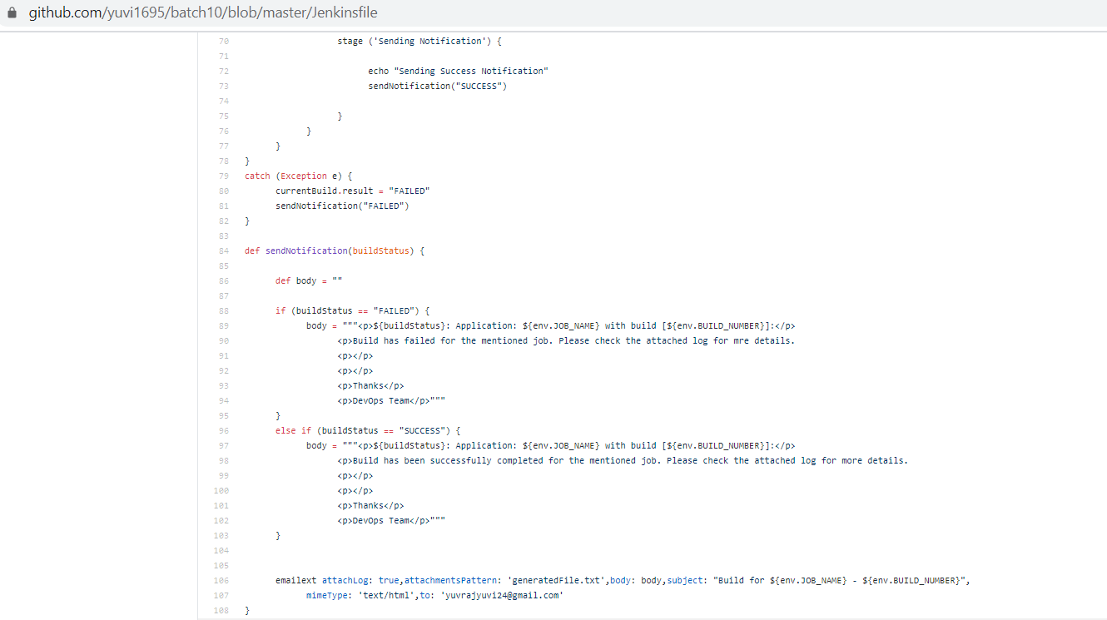

- Upload your Jenkins Log file in the Repo.(Complete log file should display your name on top).

- Attach the screenshot of Jenkins pipeline job status. (All boxes should be green)

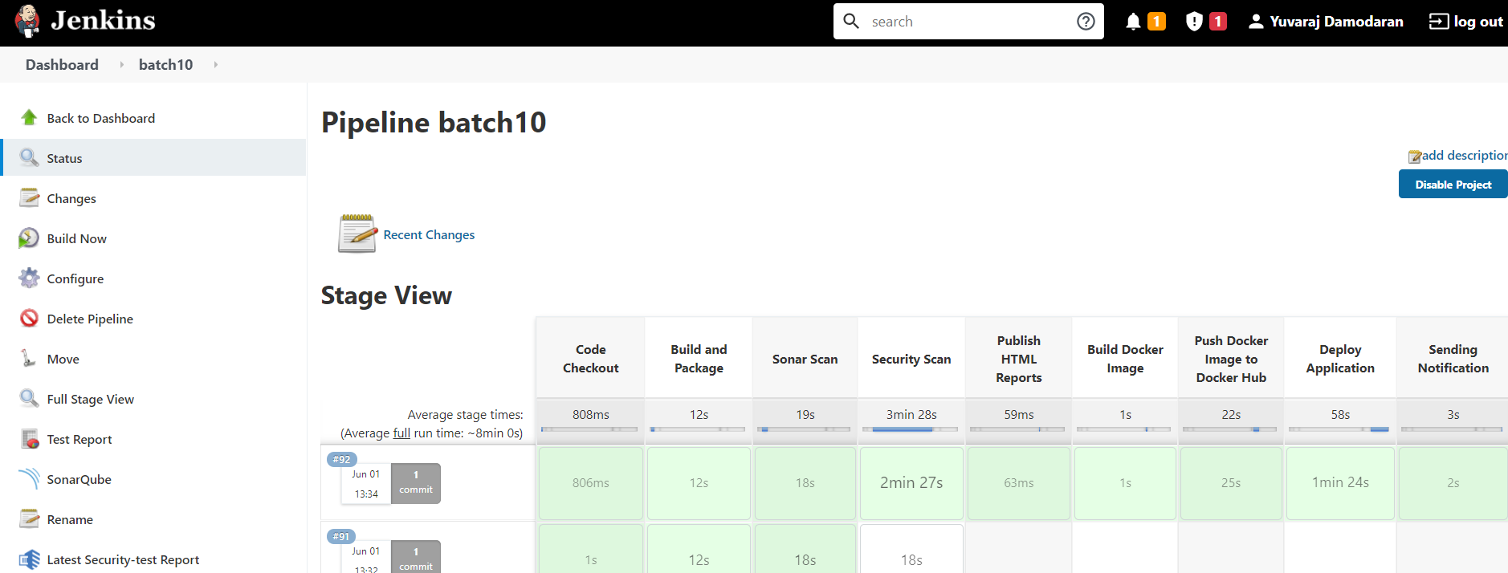

- Attach screenshots of email notification for the Jenkins build.

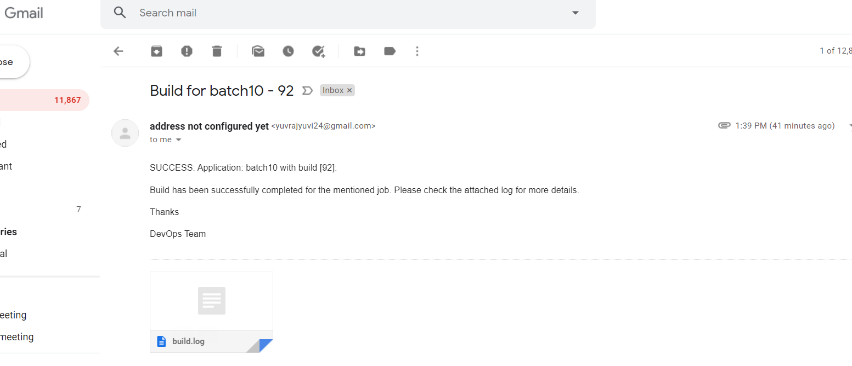

- Attach screenshot of the SonarQube Report.

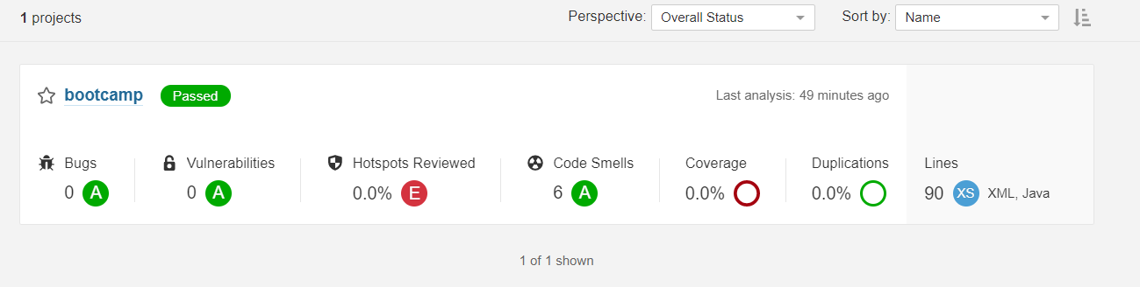

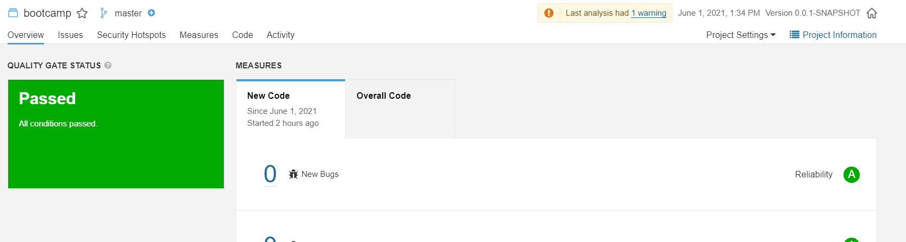

- Attach screenshot of the AppScan Report.

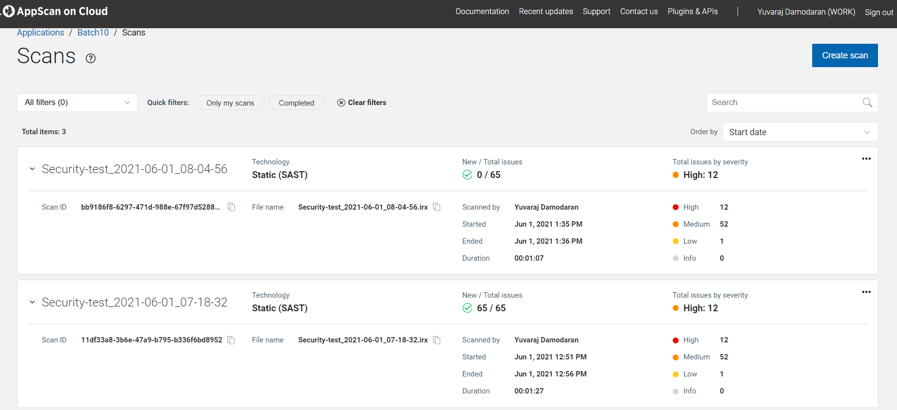

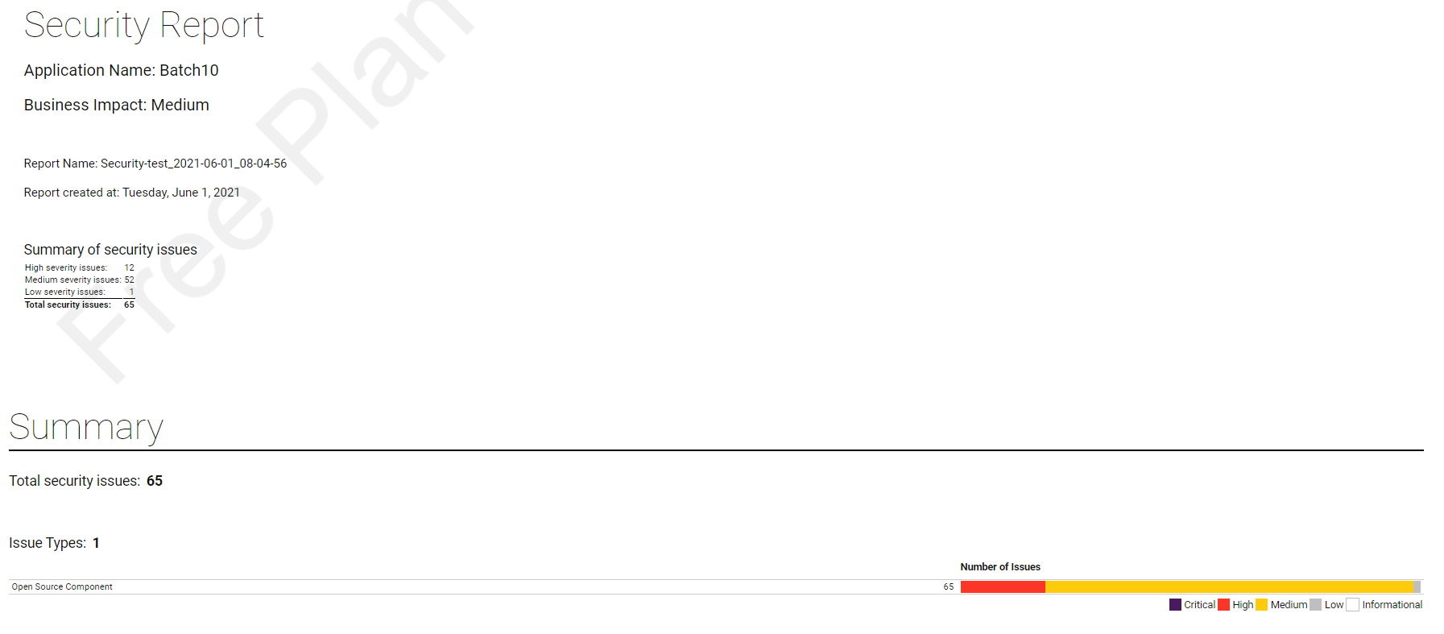
- Attach screenshot of your Ansible Playbook execution logs.

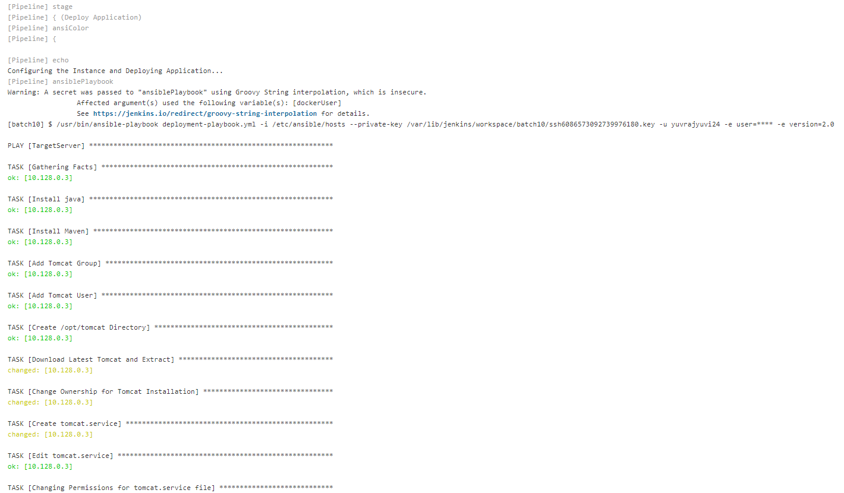

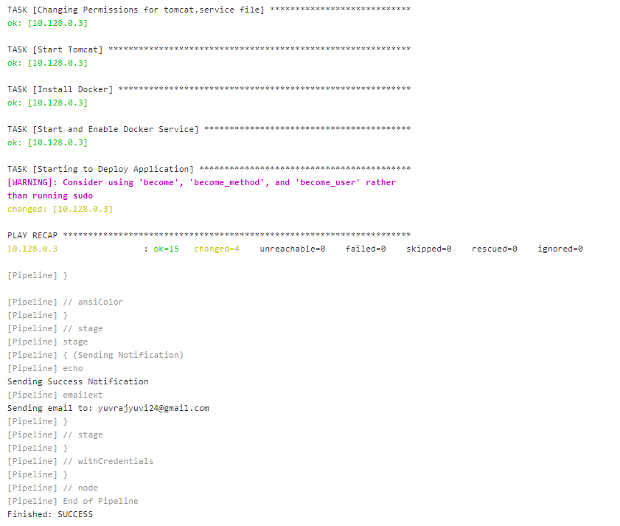

- Attach screenshot of the working application home page on AWS/GCP/Azure.

